
Mrs. Keri, Ms. Brenda, Mrs. Brooke & Ms. Kadee’s Weekly Buzz
August 16-20, 2021
Dates to Remember:
August 17: Camari’s birthday
August 22: blakeley’s birthday
August 27: wear blue & gold!!! Our TCCHS yellow jackets play Thomasville Bulldogs at 8 at Home!
Our Week In Review
It has been a rainy, educational, and fun week! We enjoyed learning more about our friends with our “All About Me” bags. We also told our friends “The Best Part of me is___”. These are always on of my favorite things! Our books this week were Rosie’s Walk & Frederick. In math we have continued getting to know our numbers. We focused on numerals 5-9. Our first decodable books went home this week. These smart kiddos did so well reading them to their teachers on Friday. Thank you for reading with your kindergartener every night.

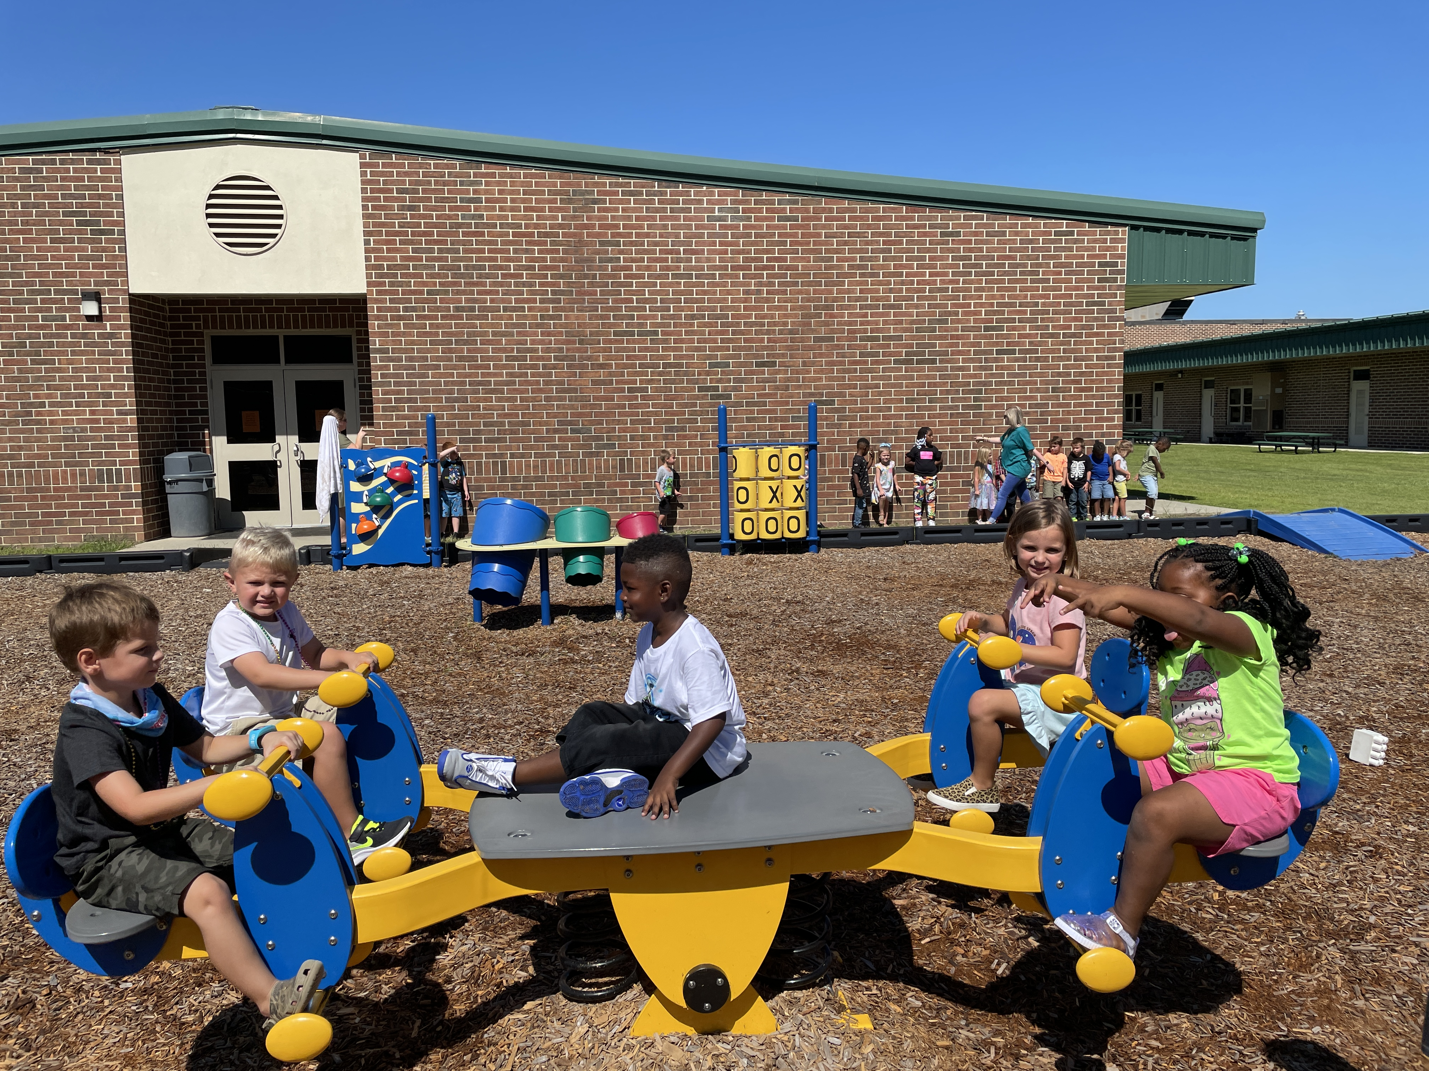

Happy Birthday Camari!



We LOVE Recess!

This week’s sight words:
I a

Finn
& Gabe
Reminders:
- Please send in water bottles everyday
- Please check folders daily

Buddies

